Mini Project 3
INFO 4340

for
Dr. Christopher Nelson

Prepared by:

Liang Lu, Bernie Dulatre and Alejandro Arboleda

Table of Contents

Table of Figures iii
List of Tables iv
Introduction 5
Method 5
Results 5
Baseline 6
Level 1 7
Level 2 8
Discussion 10

Table of Figures

Figure 1 – Showing Baseline model equation 6

Figure 2 – Showing Level 1 model equation 7

Figure 3 – Showing Level 2 model equation 9

List of Tables

Table 1 – Baseline Model results 6

Table 2 – Level 1 Model results 8

Table 3 – Level 2 Model results 10

Introduction
The purpose of this project is to build a Hierarchical Level Model to predict Student GPA during the first year in college. For the first level of the Hierarchical Level Model we will explore how Gender, Highschool GPA and ACT/SAT score variables influence the Student GPA outcome the first year. For the second level of the Hierarchical Level Model we will explore if Undergraduate enrollment, Admission Selectivity of the College and Private/Public Institution Status are influencing the average of the student GPA in the first year and if Undergraduate enrollment, Admission Selectivity and Student-Faculty ratio are moderating the predicting importance of High school GPA.

Method
The dataset consists of individual-level and school-level variables for 5,762 students at 130 colleges. In the first level dataset, the individual-level dataset, there are 10 variables. The variables used in modeling are:
- st_gpa1(Student GPA during first year in college)
- gender (Student gender)
- hscgpa (High-school GPA in core academic classes)
- besttest(Best score on ACT or SAT during high school)

In the second level dataset, the college level data, there are 11 variables. The variables used in modeling are:
- col_n(undergraduate enrollment at college)
- selratio(Admission selectivity of the college)
- stfacrat(Student-faculty ratio)
- priv(Institution public/ private status)

In level 1 model, variable St_gpa1 is the outcome variables, the predictors are gender, hscgpa and besttest. In level 2 model, col_n, selratio, priv are used to test if they are influencing the average of the outcome and col_n, selratio and stfacrat are used to test if they are moderating the predicting importance of the hscgpa.

Results
For the baseline model, we used variable st_gpal as the outcome variable. From our baseline model we obtained a reliability estimate of 0.728 and a variance component of the Intercept of 0.02779 to be used for the R² calculations for both Level 1 and level 2.

Baseline
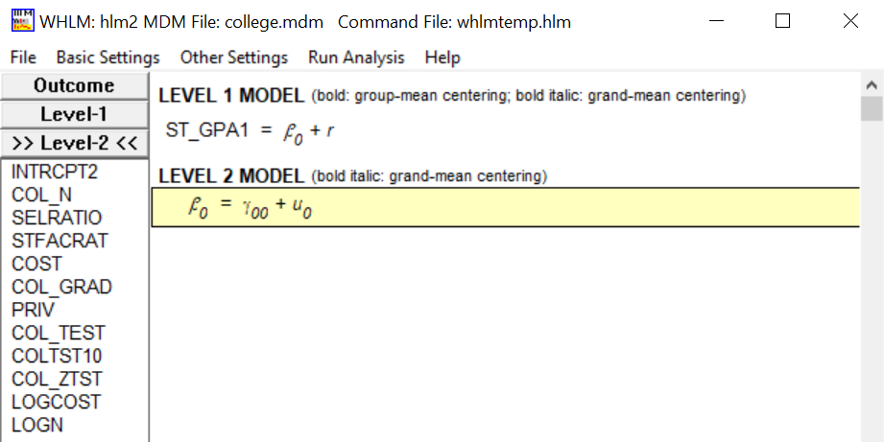

Figure 1 – Showing Baseline model equation

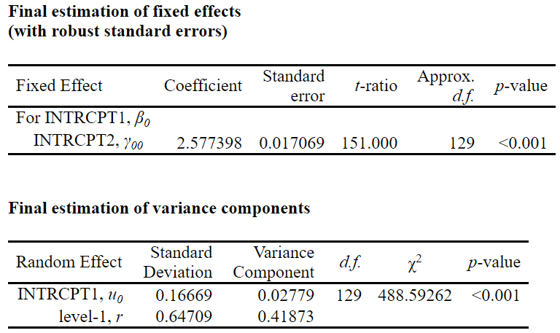
Table 1 – Baseline Model results

Level 1

For the level 1 model, we add variables gender, hscgpa and besttest as the independent variables. Since gender is a binary variable, it is uncentered and other two are grand centered. From our Level 1 model we obtained a reliability estimate of 0.800 and a variance component of the Intercept of 0.02565 which give us an R² of 7.7%.
It is showed from the model that the intercept, which is the average st_gpa1 is 2.65. The p-value of all three independent variables are less than 0.001, meaning that they are all significant predictors. The coefficient of gender is -0.11, meaning that if the student is a male, then the st_gpa1 will reduce 0.11. The coefficient of hscgpa is 0.52, meaning that if the hscgpa increase one unit, then the st_gpa1 will increase 0.52. The coefficient of besttest is 0.001, meaning that if the besttest score increase one unit, then the st_gpa1 will increase 0.001.

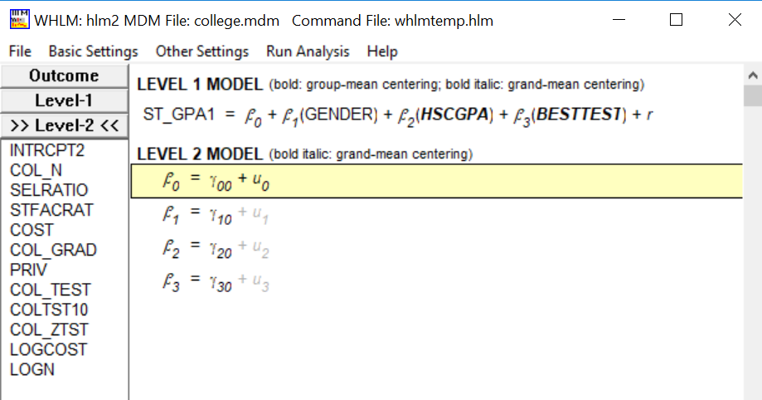
Figure 2 – Showing Level 1 model equation

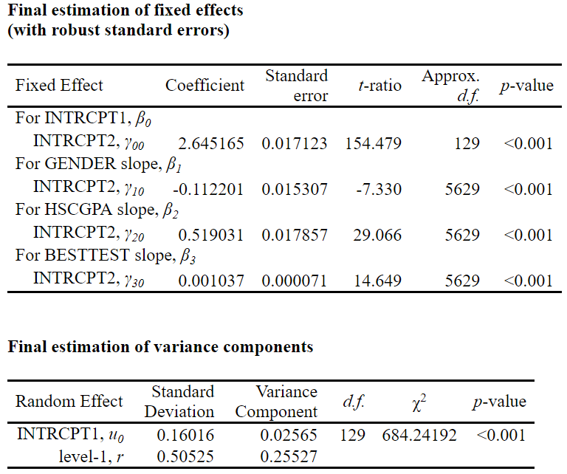

Table 2 – Level 1 Model results

Level 2

For the level 1 model, we add variables col_n, selratio, priv to check if they are influencing the average of st_gpa1 and variables col_n, selratio and stfacrat to test if they are moderating the predicting importance of hscgpa. Priv is uncentered since it is a binary variable and other variables are all grand centered. From our Level 2 model we obtained a reliability estimate of 0.523 and a variance component of the Intercept of 0.02117which give us an R² of 23.82%.

It is showed that variables col_n and Priv are not significant variable when coming to influencing the average value of st_gpa1since there p_values are greater than 0.05. Variable selratio is a significant variable and it increases the average st_gpa1 by 0.004, changing the average st_gpa1 from 2.6426 to 2.6458. With that said, it is concluded that variable selratio slightly increased the average st_gpa1.

From the final estimation, it is found that all three variables are moderating the coefficient of hscgpa since their p_values are all lower than 0.05. Variable selratio and stfacrat increase the coefficient by 0.003 and 0.007 respectively while variable col_n reduces it by 0.00006, changing the coefficient of hscgpa from 0.5249 to 0.5346. It is learned that these three variables all together slightly increased the coefficient of hscgpa.

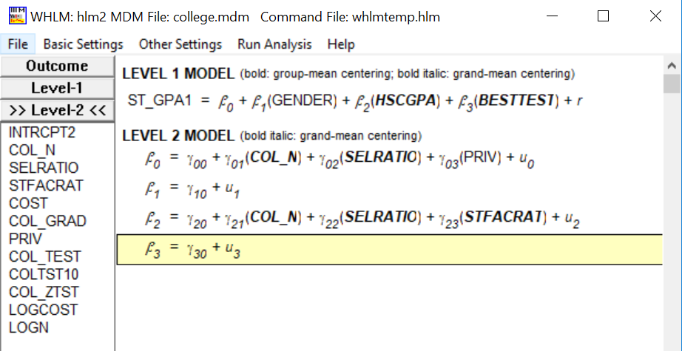
Figure 3 – Showing Level 2 model equation

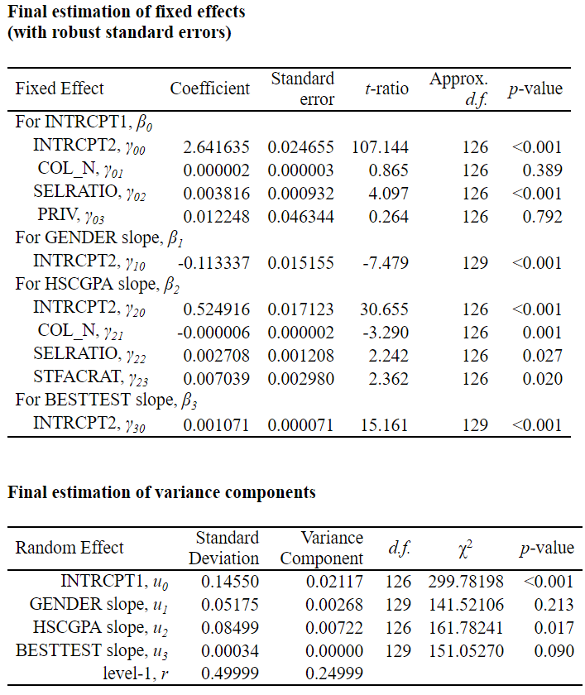
Table 3 – Level 2 Model results

Discussion
To get a better understand of how the student gpa in the first year are influenced by different variables, the model can should take more variables into consideration and try to modify the model based on the p-value of the variables and the practical requirement. At the same time, models should be built to test if variables are moderating the predicting significance of the level 1model variables.
One thing needs noticing is that the for the baseline, level 1 and level 2, the reliability estimate outcomes are both lower than 0.9 which introduces noise into the model. The reliability estimate of the baseline model is 0.728, which increased to 0.8 when we add variables gender, hscgpa and besttest. However, when we add more variables to test their influences to the average gpa and their impact on the predicting significance of hscgpa, the reliability estimate dropped sharply to 0.523, indicating much noise are introduced.

